Introduction to Creating Graphs and Tables for the Tax Policy Center



Table of Contents

A. Tools Palette 2
B. Setting up a Workspace 3
C. Suggested Font Sizes 3
D. Creating Graphs 3
E. Creating Tables 14
F. Saving Graphs and Tables 18
G. Specials 19
H. Examples of Graphs and Tables 20

A. Tools Palette

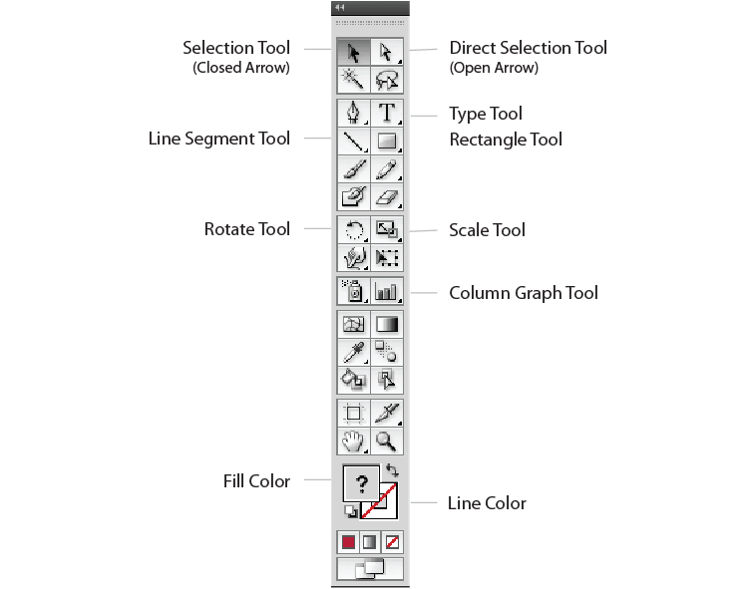

B. Setting up a Workspace

Create a workspace by opening the following
- Swatches—Small List View
- Align
- Color
- Layers
- Stroke
- Tools
- Type–Character View

C. Suggested Font Sizes

- Font = Universe Ltd. Std, 57 condensed
  - Title: 15 pt, bold
    - Include Figure 1. Capitalize first letter of each major word in the title
  - All other: 12 point, regular
    - Capital first letter and lower case all other except proper names and acronyms
- Use colors in SWATCHES, small list view and try to follow color scheme in rest of briefing book

D. Creating Graphs
1. To create a graph, open the "TPC_Graphics.ai" template in Adobe Illustrator (saved K:\Ibp\BBROWN\CENTER\TaxPolicyCenter\Website\Web Graphs\Graph Instructions) the Each graph will need to be on a separate layer.

2. Open windows on workspace Create New Layer. Go into layer window and create new layer. Duplicate wide or Narrow Graph Frame, or if there is a graph that looks like what you want to do, duplicate that graph, give it a new name

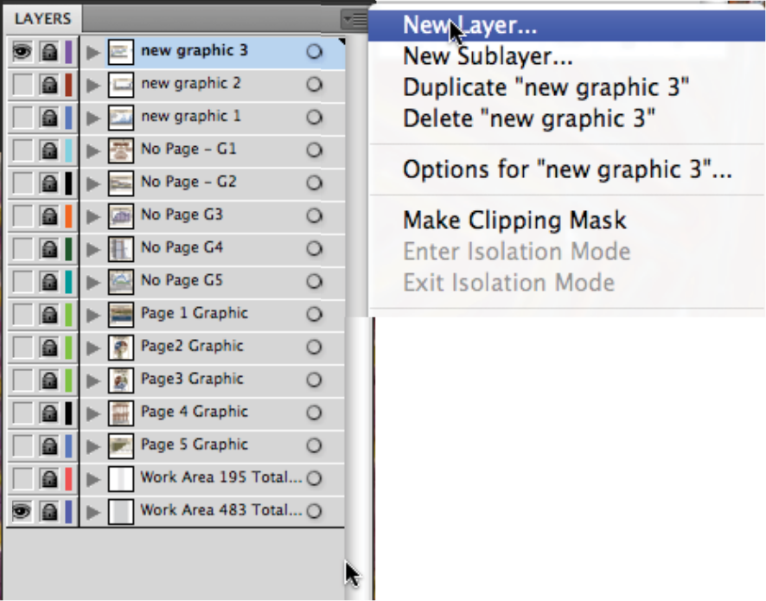

3. To identify and move more easily between layers, each layer should have its own name. To name a layer, go to the upper right selection box in the Layers palette (Menu: Window/Layers), select "New Layer", and type the name.

4. To use judge window width, go to the Layers palette and turn on visibility for the work area (195 for narrow graph or 483 for wide graph). 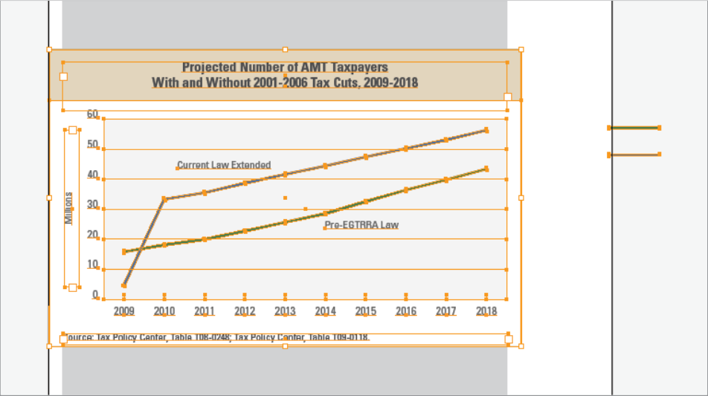

5. To unlock a separate completed graph layer, go to the Layers window, select all (control A), and then copy (Menu: Edit/Copy). Then, re-lock that layer and select the newly created, newly named layer. Once the new layer is highlighted, select Paste in Front (Menu: Edit/Paste in Front). Use the closed arrow tool to delete any graph elements that aren’t needed. Keep the outer box, title, source, etc.

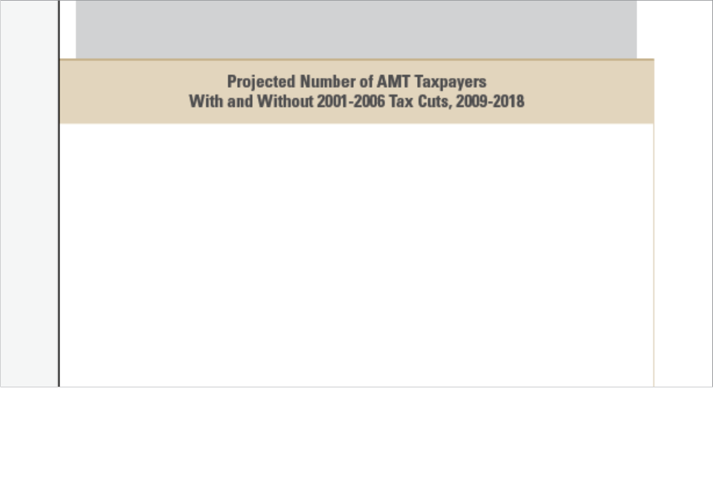
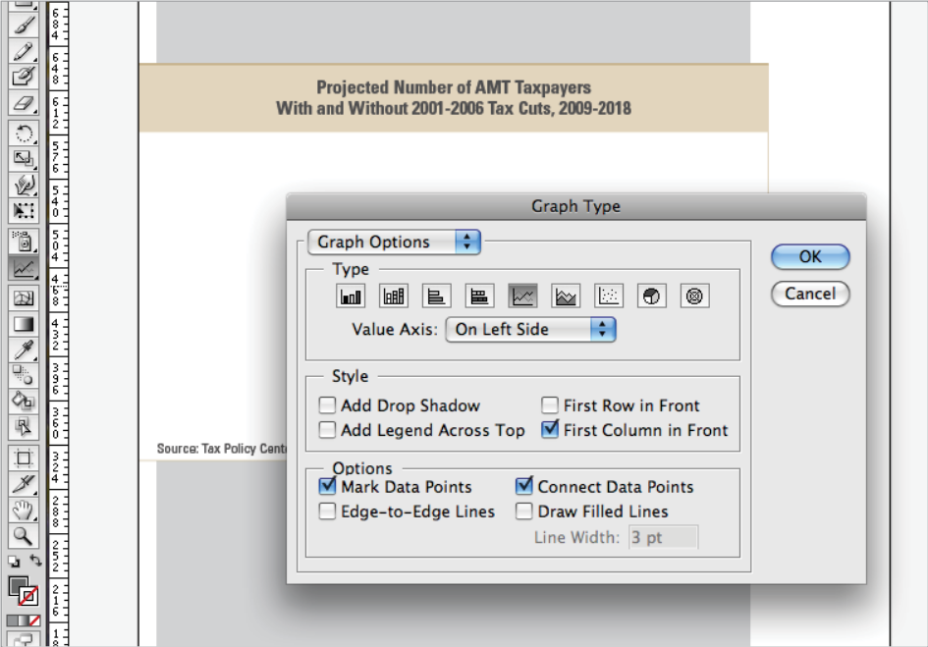

6. In the Tools palette (Menu: Window/Tools), double click on Graph Tool and select Graph Type, Style, and Options. Under the Graph Options drop down, choose Value Axis and Category Axis to customize their settings, then click “OK.” These settings can be adjusted later as well. Next, click and drag the width of the work area (195 or 483) to create the initial graph.

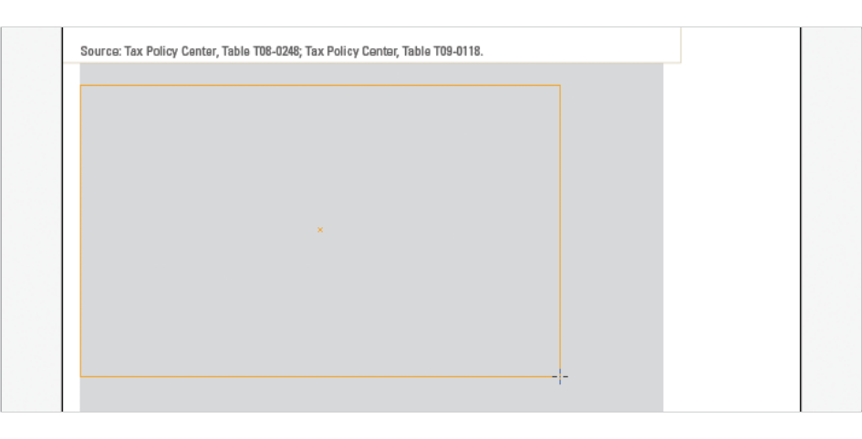

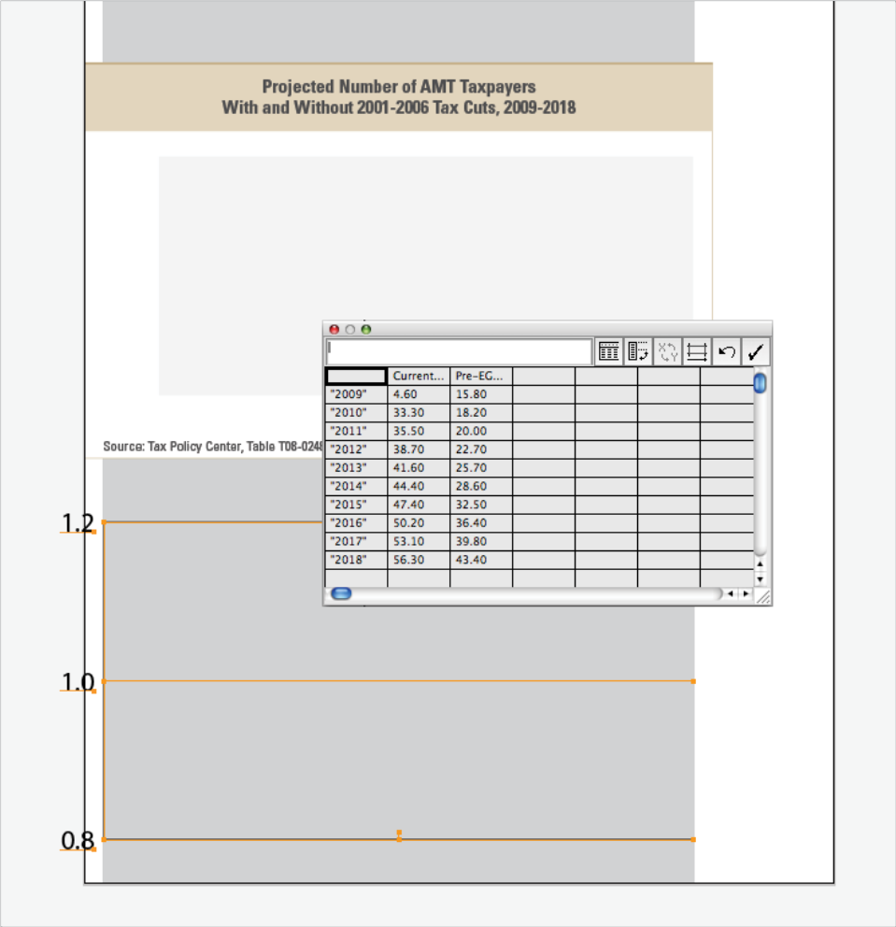

7. Enter data into the Data Input area. Use quotation marks to indicate what needs to appear in the category axis (e.g., years, state names, etc.). Then, click the check box in the Data Input to see the results.

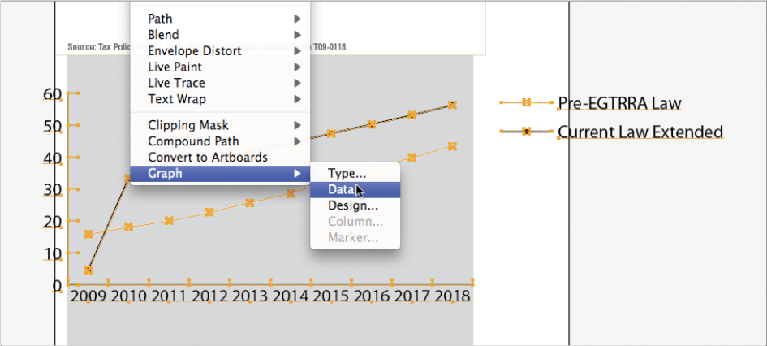

8. Once the initial graph is created, fine tune the graph by changing type, inverting data, etc. To make changes to the graph, use the closed arrow tool to select the graph, then under the Menu, choose Object/Graph/Type or Object/Graph/Data.

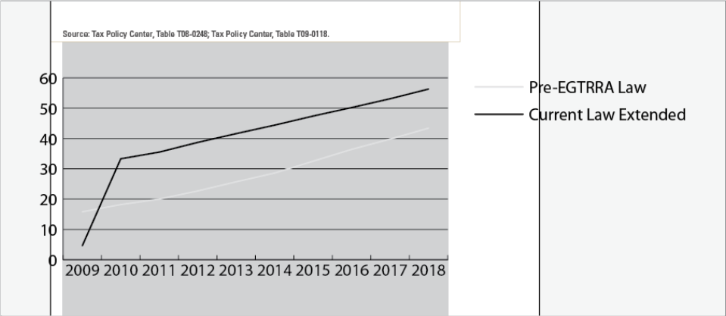

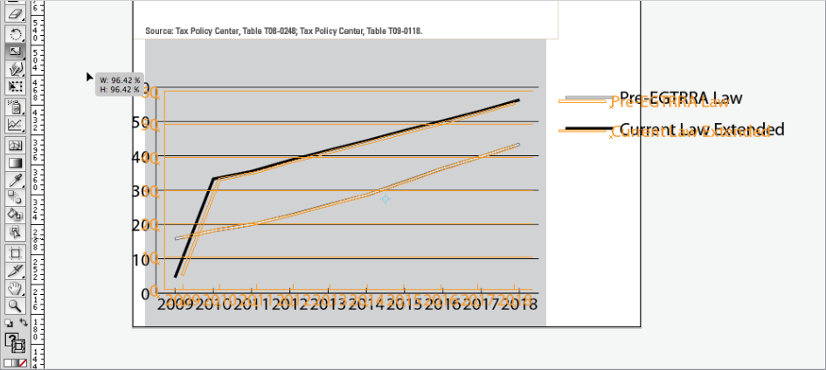

9. Ensure the graph fits into the work area by using the Scale tool. Double click on the Scale tool icon in the Tools palette to scale up or down uniformly by inputting a percentage, or click on the Scale tool once to scale the selected graph by hand. Click and drag while holding the shift key to constrain proportions.

10. To move the whole graph, click on the graph with the closed arrow tool and drag. To move it using the keypad, click on the graph with the closed arrow tool to highlight, then use the keypad arrows to move the selected graph one pixel at a time. Note: to move in increments of 10 pixels, hold down the shift key and use the keypad arrows.

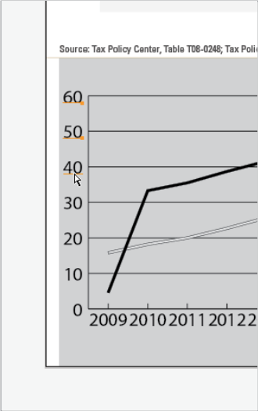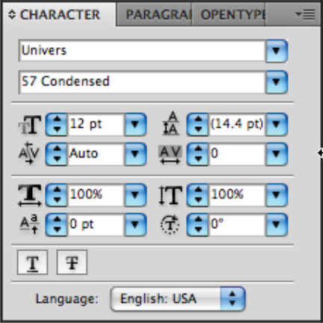

11. To select and size axis information, use the open arrow tool and hold down the shift key. Axis font size should be Univers Condensed Regular 12 point, and Legend font size should be 11 point.

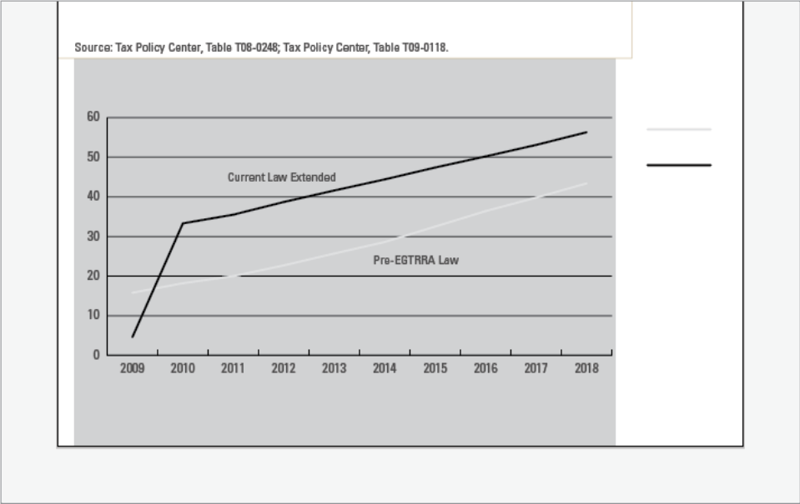

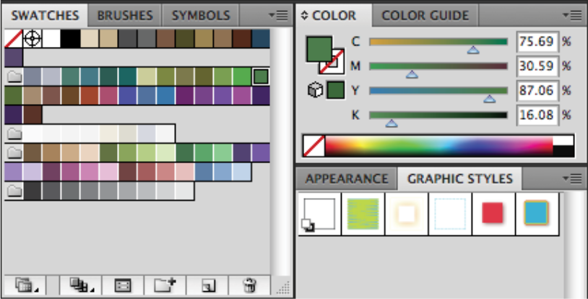

12. Use the open arrow tool to select like graph elements, and the Swatches Palette (Menu: Window/Swatches) to change the color. Use the color palette to alter a stroke or a fill, and the "no color" box to turn off a stroke or a fill. Change black elements (e.g., axis lines and text) to gray, bars to color, longer tick marks to white, etc.

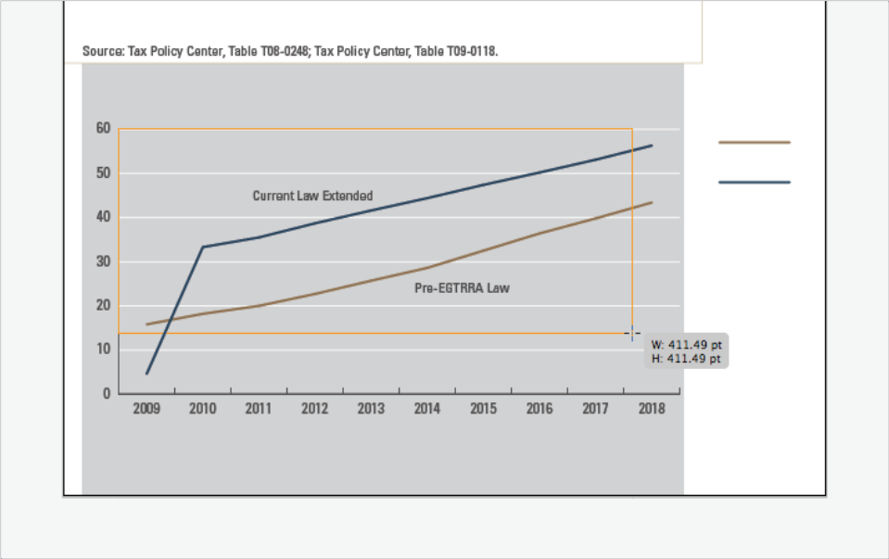

13. Use the Rectangle tool in the Tools palette to click and drag a block of color for use behind the graph. Make sure to select the graph with the closed arrow tool and bring the graph to the front. (Menu: Object/Arrange/Bring To Front).

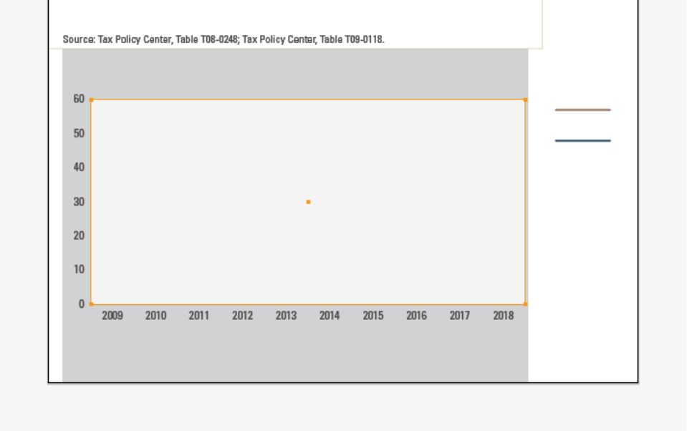

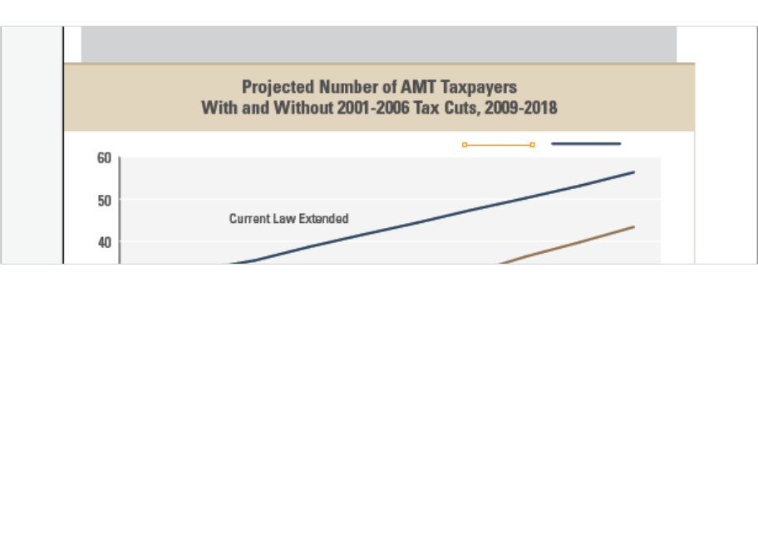

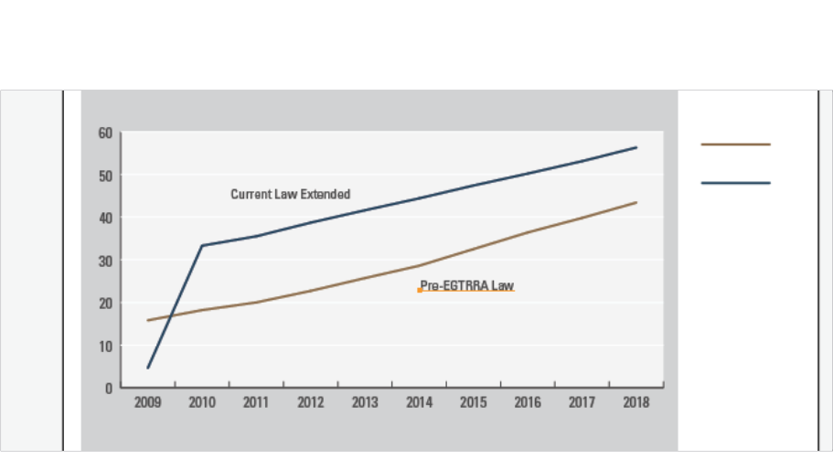
14. To select both the graph and the block of background color, use the closed arrow tool and hold down the shift key. Then, move the graph and background color to inside the outer graph frame and title area.

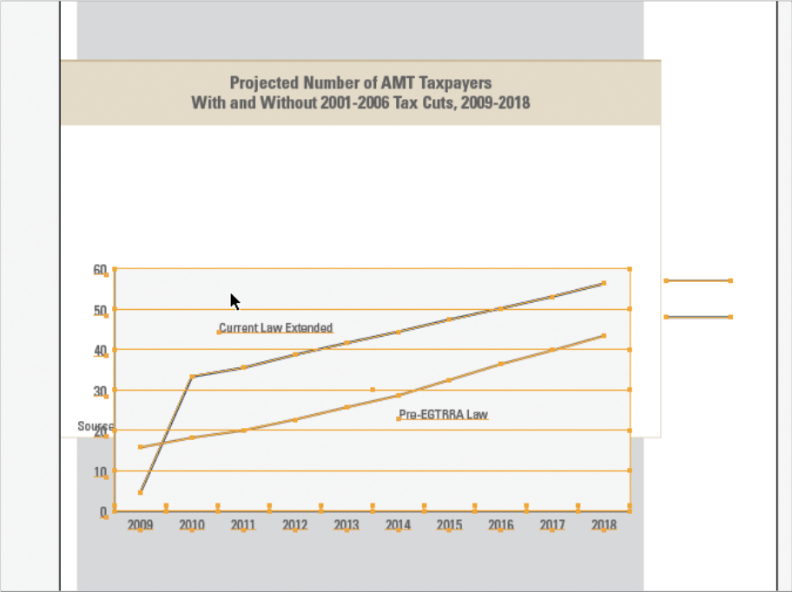

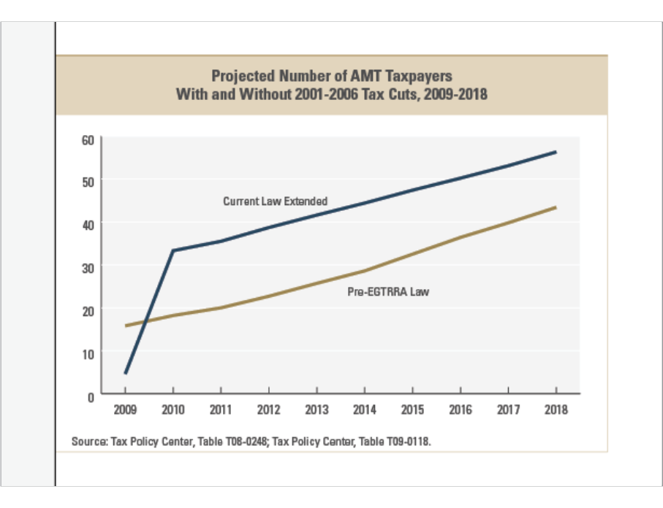

15. Remember to change the title and the source. Make any additional adjustments to the frame around the graph, making sure spacing is correct. When selecting a line with the open arrow tool, use the arrow and shift keys to open or close the box. Make sure to hide any key elements from the graph within the graphic. Turn elements to white to hide when saving. When you think you have a final product, hit control A. If there are unwanted marks outside of the box, hit view/outline so you can see where they are. Delete unwanted marks or elements.

16. Turn off work area layer or any other layer than shouldn't be in the final output.
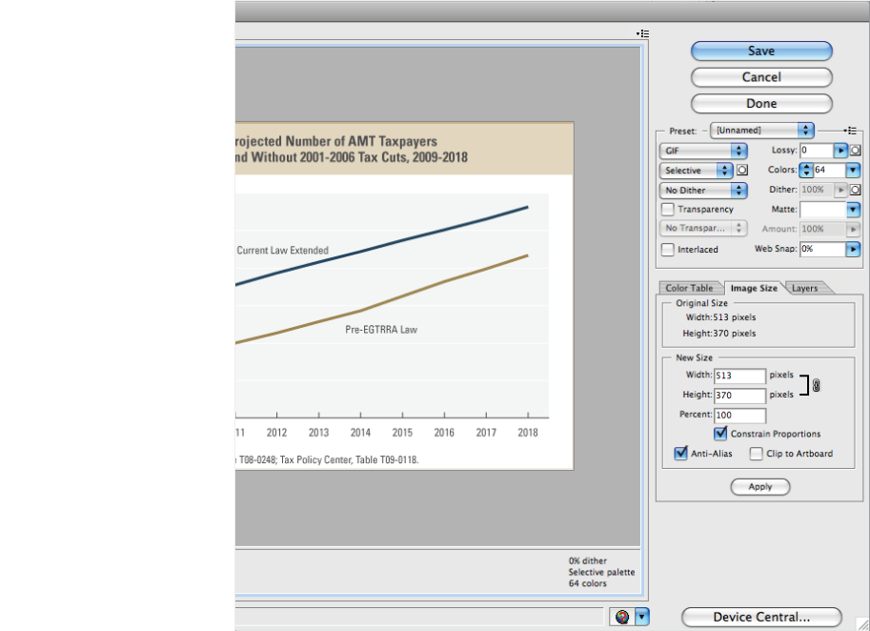

17. Lastly, if the graphs are for the web, go to the Menu and click on File/Save for Web & Devices. Then, choose the 2-Up tab in the upper left to see the original and optimized versions. Most graphs should be saved as a gif file. Reduce the number of colors without compromising the image. Turn off dithering. Under the tabs on the right, select "Image Size" and un-check "Clip to Artboard." This should close the image being saved to the correct size. Make sure "Transparency" is unchecked. Then, click Save and Name the File.

18. If the Graph is for paper you will need to save as a JPG by clicking Export. Save as a JPG.

E. Creating Tables

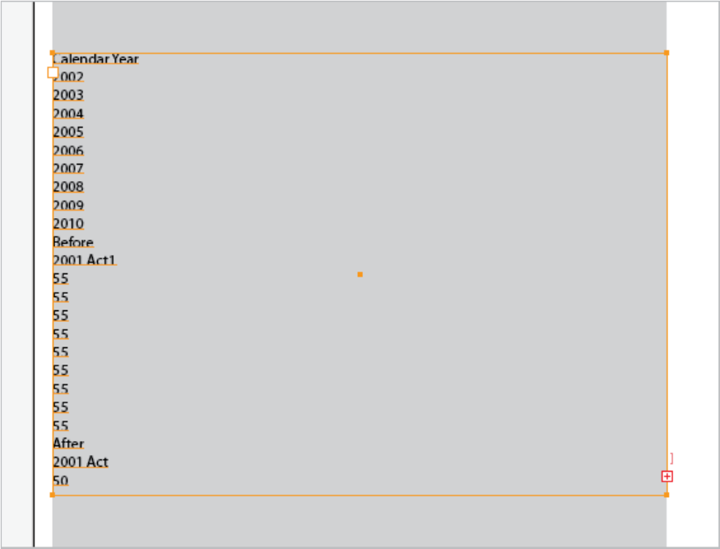

- To create a table, turn on a work area within the layers Palette. Create a new layer, then click and drag a text box across the width of the work area. Paste the data for the table into the text box.

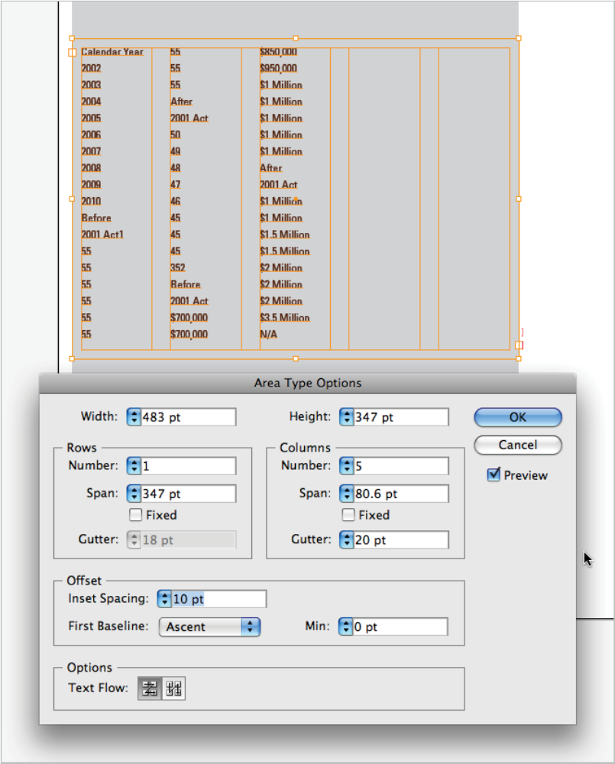

2. With the text box selected, go under Menu/Type and click on Area Type Options to select the number of rows and columns. Select gutter width and inset spacing (this adjusts the area between rows and columns, as well as outside the box). Make sure the Preview box is checked to see changes in real time. Once ready, click OK.

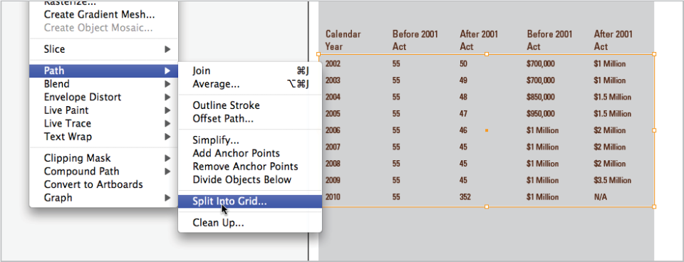

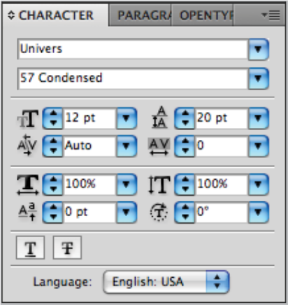

3. Next, format the type. Use 15 point bold for titles and 12 point regular for text inside the chart. Use the character palette to set the leading to ensure good spacing between lines. You may also color the fonts. In the tools palette, select the rectangle tool and draw a box around the area in which you would like to create the grid. Make sure the box contains a stroke but turn off the fill.

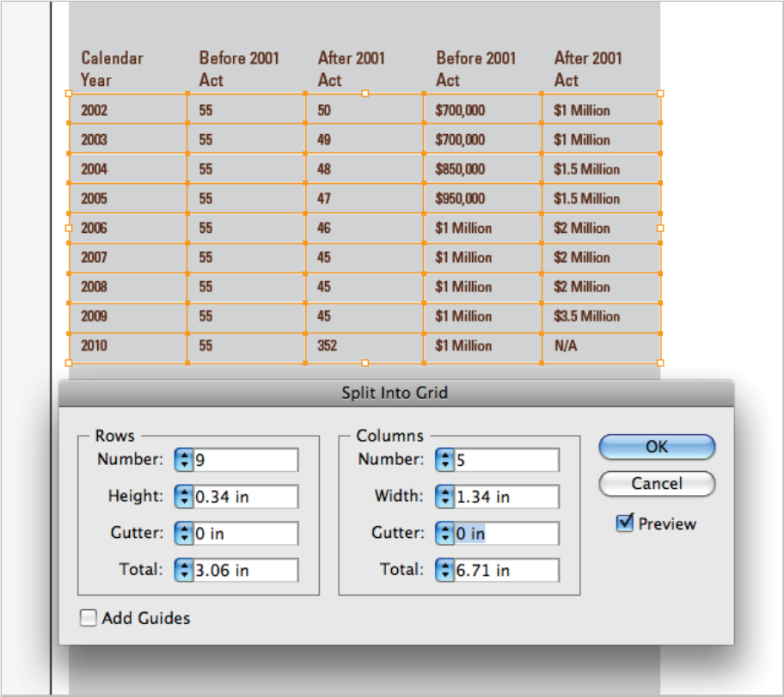

4. With the rectangle highlighted, go to Menu/Object/Path and select Split Into Grid. Input the number of rows and columns. Set the gutters to zero so there won’t be a space between each box. Make sure the Preview box is selected to see changes in real time. When finished, select OK.

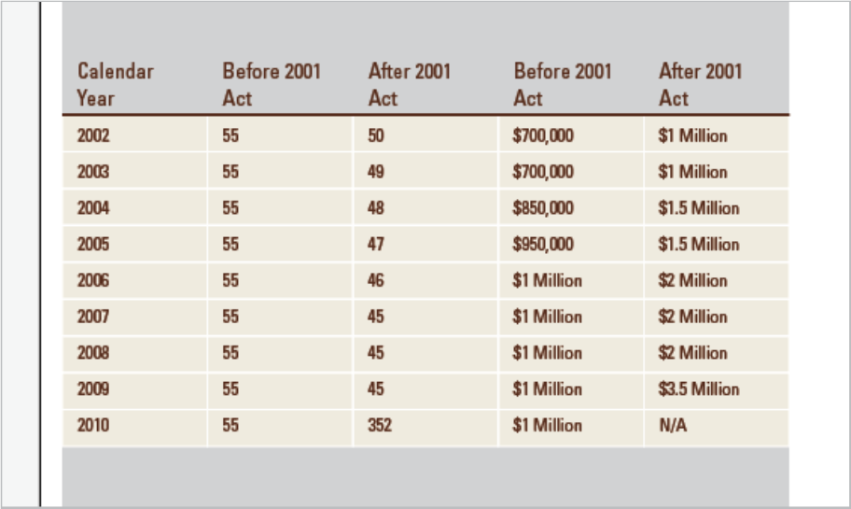

5. To add background color, use the rectangle tool from the Tools palette. Under menu, choose Object/Arrange/Send to Back. To separate the headings from the data, use the Line tool in the Tools palette and add a 2-pixel line at the top of the grid. Turn off the work area layer.

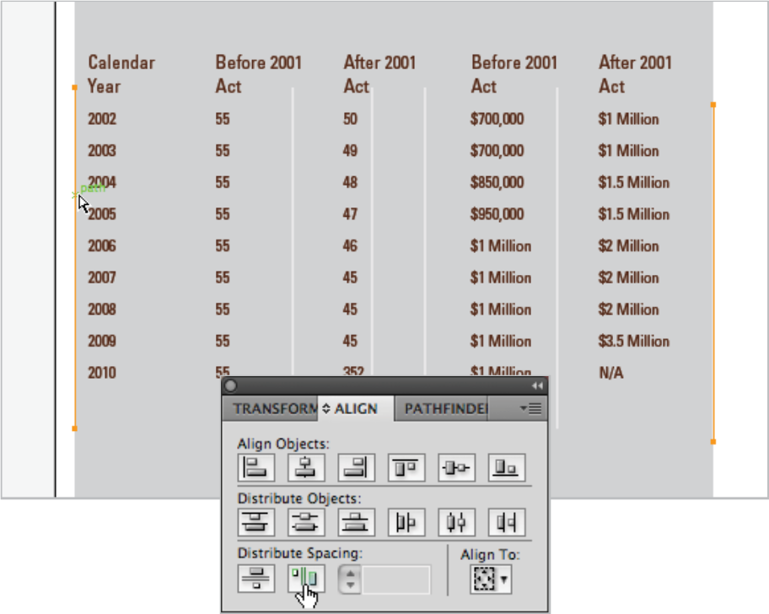

6. To create a table that uses lines only, go to the Tools palette and choose the Line Segment tool. Draw the first line on the outer edge of your work area while holding down the shift key to assure it is straight. While the line is highlighted, select Menu/Copy, then select Menu/Paste in Front. A new line will appear on top of the first. Using the closed arrow, hold the shift key and drag the line across to set in between text. Repeat this process until the last line is anchored to the opposite side of the work area. Next, using the closed arrow tool, hold the shift key and select all lines to distribute, including the outer two. Under the Menu, select Window/Align to open the toolbox. Under Align To: dropdown, select Align to Selection, then select the Distribute Spacing button. Once the lines are distributed, select Object/Group. Perform the same process as above with horizontal lines.

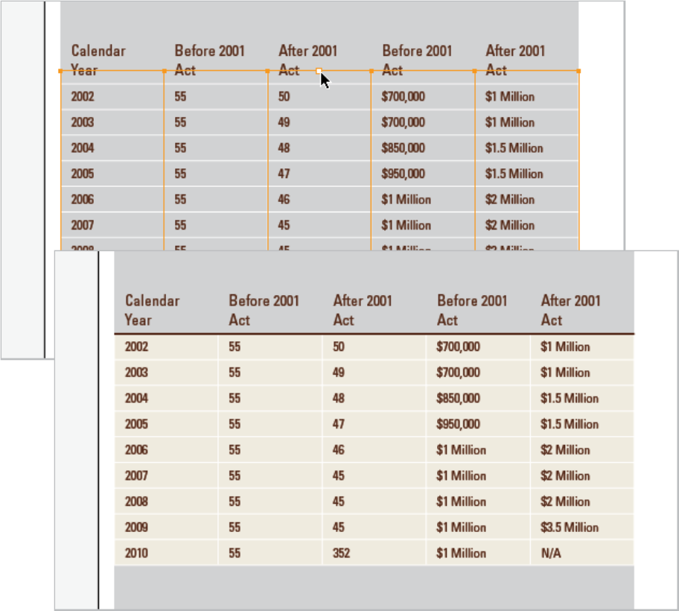

7. Select the group of vertical lines and use the closed arrow tool to drag them to the top and bottom horizontal lines. Add in the 2-point stroke with the line segment tool, as well as add the background box and send to the back. Turn off the Work Area Layer.

F. Saving Graphs and Tables

- Web - Save for Web and Devices, GIF Format, turn off transparency, Colors=64 or 128, No dither (use only when gradients), Interface=off, save

- Paper - File Export, Name_high.jpg, max quality, CMYK=color model, Baseline standard, depth=high or medium, Anti Alias=check (smooth, not jagged), check embedded icc profile, ok.

G. Specials

- To copy an image: Alt, Shift, Drag

- To move a large group of objects in a different direction: black arrow, shift, click a couple of time until you get what you want. If you don’t push the shift key, you get smaller movements.

- To standardize the font: open arrow +, double click to highlight entire set, window, type, character, click on the three lines (top right hand side of the character window) and reset panel.

- Show bounding box allows you to see the small boxes that allow you to adjust the size of the bounding boxes.

- Show edges to see edge of bounding box when you’re in it.

H. Examples of Graphs and Tables

